Here’s a description straight from an AI how they can fall into this “trap” of repeating a lie all the while fully appearing to be presenting the truth (take note that it is by design that they operate this way. It’s not an accident it is on purpose):
This is a brief and concise summary of how AI models are trained and how they become subject to the "echo chamber" effect:

How AI Models Are Trained (The Basics)
- Data Collection: Large Language Models (LLMs) are trained on vast quantities of data, primarily text from the internet (books, articles, websites, social media, etc.). This data forms their entire knowledge base.
- Pattern Recognition: The model processes this data to recognize and learn patterns, relationships, and the statistical frequency of words and concepts. It is not learning truth or facts; it is learning what information is most common and what words typically follow others.
- Prediction: The model's core job is to use these patterns to predict the most probable next word or sequence of words in response to a prompt, resulting in a coherent-sounding answer.

How They Fall to the "Echo Chamber" Effect
The "echo chamber" in this context is not about filtering content to match your personal preferences, but about the bias inherent in the model's training data.
- Training Data Bias: If a piece of incorrect or overly simplified information is repeated frequently across the internet (e.g., a common but flawed explanation of "thy vs. thine"), the AI assigns it a high probability of being "correct" because it has been echoed so many times in its source material.
- Prioritizing Frequency over Authority: The model cannot fundamentally distinguish between a thousand casual blog posts that repeat a mistake and one definitive, scholarly source (like the exhaustive text of the Authorized King James Version) that contradicts it. It simply replicates the statistical majority of its training data.
- Confident Error: The model is highly effective at generating an articulate, fluent, and highly confident response based on the prevalent patterns it has learned. However, when the prevalent pattern is wrong, the AI will confidently and eloquently "repeat the lie" that was already embedded in its echo chamber of training data.

So here’s the basic steps:
- Research what is the most common knowledge of what is available on the Internet.
- Rank those results based, not on truth, but frequency (how often they occur).
  - The “opinion” that shows up most often becomes your “truth”.
    - Even secular researchers don’t do research this way. So, who does research this way and who thinks this method is a good idea?
- Produce an answer that appears to be coherent.
  - A “coherent-sounding” answer is just another way of saying “a lie that looks good”.

And this is how AI responses can be so hilariously flawed. Their method is flawed right from the foundation because it’s not based on truth (Matthew 7:24-27). It’s not even based on any known reasonable attempt to ascertain truth.

Remember, some of the richest men in the world are investing billions into this technology to spread it far and wide. Why is such flawed technology spreading so quickly and so easily with so little resistance?

And here is a simple example of what happens when you try to use AI to give you advice on truth:

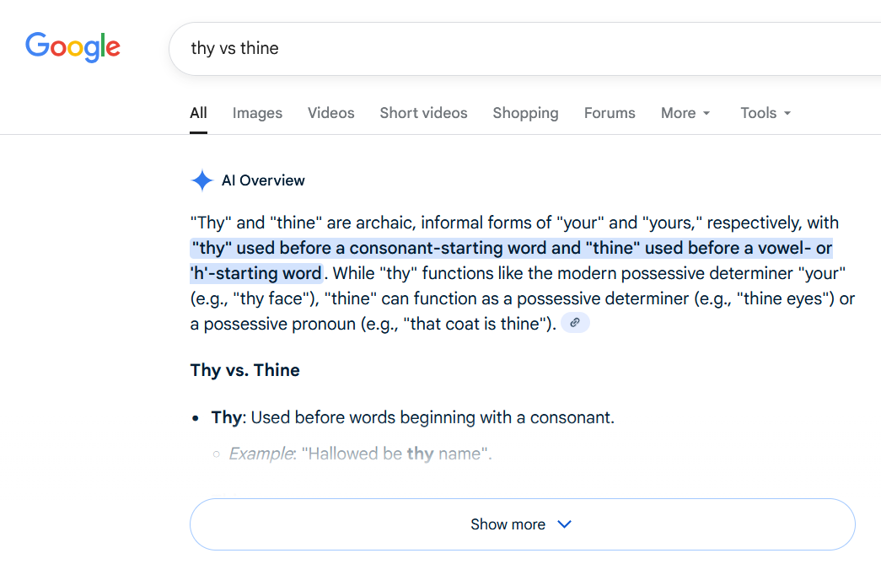Result gathered on 2025-10-17 from the Google Gemini AI model.

Sounds good right? Only one problem: it’s not the truth (John 17:17). There are 52 examples in the Holy Bible that prove the statement made by the AI model to be false. Here they are:

“thy” followed by a vowel | “thine” followed by a consonant (and not h)
Gen 15:1 thy exceeding | Gen 31:32 thine with
Gen 16:11 thy affliction | Deu 15:3 thine with
Gen 31:38 thy ewes | Deu 30:4 thine be
Gen 48:6 thy issue | 1Ch 21:24 thine for
Exo 23:11 thy oliveyard | Jer 32:7 thine to
Exo 33:5 thy ornaments | Joh 17:6 thine they
Lev 2:5 thy oblation
Lev 2:7 thy oblation
Lev 5:15 thy estimation
Lev 5:18 thy estimation
Lev 6:6 thy estimation
Lev 27:2 thy estimation
Lev 27:3 thy estimation
Lev 27:3 thy estimation
Lev 27:4 thy estimation
Lev 27:5 thy estimation
Lev 27:6 thy estimation
Lev 27:6 thy estimation
Lev 27:7 thy estimation
Lev 27:8 thy estimation
Lev 27:13 thy estimation
Lev 27:15 thy estimation
Lev 27:16 thy estimation
Lev 27:17 thy estimation
Lev 27:18 thy estimation
Lev 27:19 thy estimation
Lev 27:23 thy estimation
Lev 27:25 thy estimations
Lev 27:27 thy estimation
Deu 12:17 thy oil
Deu 21:2 thy elders
Deu 32:7 thy elders
Deu 33:29 thy excellency
1Sa 25:33 thy advice
1Ki 10:6 thy acts
2Ki 19:27 thy abode
Job 15:12 thy eyes
Psa 20:3 thy offerings
Pro 24:14 thy expectation
Isa 37:28 thy abode
Isa 60:17 thy officers
Eze 16:36 thy abominations
Eze 23:40 thy eyes
Luk 2:35 thy own
Phm 1:21 thy obedience
2Jo 1:13 thy elect

It get’s even worse when you look at how the AI defines each word:

thy: “functions like the modern possessive determiner ‘your’”. What’s the problem with that you might ask? “your” can be either singular or plural (it’s both) whereas “thy” is only and always singular. If you put “your” in place of “thy” you can then completely change the meaning of a sentence, a verse, or even a doctrine. The AI doesn’t even bother to warn you that “your” and “thy” cannot be used interchangeably. In fact, it gives the opposite impression.

Thine: “can function as a possessive determiner or possessive pronoun”. This definition is better but it’s still missing the most important part: “thine” is only and always singular.

As you saw, and can see, from any AI model, they have no interest in learning the truth and that’s by design. They simply repeat (or echo) what is most common. Ask yourself a simple question: which is more common in the world (and documented on the internet)? Truth or lies?

If you don’t think that the devil is using this very technology to deceive millions every day at an increasingly alarming rate then at least remove your head from the sand long enough to make sure that you aren’t one of those being deceived.

